Dubuffet, Jean (1901-1985)

Although he had tried his hand at art earlier in life, it was not until 1942, at the age of forty-one in German-occupied France, that Jean Dubuffet committed himself to producing art full-time. An extraordinarily experimental artist who embraced unconventional materials and investigated different media, Dubuffet’s style and content varied greatly throughout his career. In the fall of 1944, Dubuffet held his first solo exhibition at Galerie René Drouin in Paris. Exhibiting garishly colored paintings featuring the mundane subjects of everyday life, including cows and suburban street façades executed in a crude, flat, and graffiti-like manner, Dubuffet agitated many critics with his perceived adoption of an anti-establishment aesthetic and philosophy. Nonetheless, he quickly ascended on the Paris and American art scenes upon his development of a technique - influenced by the thickly impastoed works of Jean Fautrier - in which he often incised compositional forms into thick layers of paint that had been mixed with materials including grit, gravel, and glass. The resulting textured, highly complex surfaces were a feature of Dubuffet’s most well known works of the 1940s, including his series of caricatured and unflattering portraits of intellectuals in the circle of Jean Paulhan, the writer and editor who could be considered Dubuffet’s most important early champion. Dubuffet was a co-founder of the Compagnie de l’Art Brut in the late 1940s.
After introducing his complex paint mixtures in the 1940s, Dubuffet began to incorporate butterfly wings, tree bark, and cut up fragments of his own paintings and works on paper into his two dimensional works and he began creating three-dimensional assemblages of found, but manipulated materials. He also experimented in different genres, including bookmaking, lithography, writing, and music. In the 1960s, Dubuffet moved away from his treatment of themes inspired by the everyday subjects of the real world in order to pursue his so-called Hourloupe cycle. Instigated by doodles made in pen while he was on the telephone, these works explored interior, mental constructs and featured cellular, organic shapes made in red, blue, black, and white. This style dominated Dubuffet’s later artistic production and transferred into his forays in performance and monumental sculpture.
Dubuffet was highly productive during his four-decade career. In addition to his artistic output, he also played a critical role in the shaping of his own legacy by overseeing the production of his own 38-volume catalogue raisonné, by establishing his own Foundation, and by writing extensively about his artistic philosophy as well as his own autobiography shortly before his death in 1985. Dubuffet also forged a name for himself in relation to his investigations of art brut (raw art) and his status as co-founder of the Compagnie de l’Art Brut. While the concept of art brut was a slippery one, it most generally could be defined as work produced by untrained art world outsiders. Often rough and schematic, the examples of art brut that Dubuffet collected featured formal characteristics that often resonated with the type of work that he himself fervently produced.

References and further reading

Abadie, D. (ed.) (2001) Dubuffet, Paris: Centre Pompidou.

Damisch, H. (ed.) (1967-95) Prospectus et tous écrits suivants, Paris: Gallimard.

Dubuffet, J. (2001) Biographie au pas de course, Paris: Gallimard.

Loreau, M. (ed.) (1966-91) Catalogue des travaux de Jean Dubuffet, vols. 1-38, Paris: Pauvert.

http://www.dubuffetfondation.com/index_ang.htm

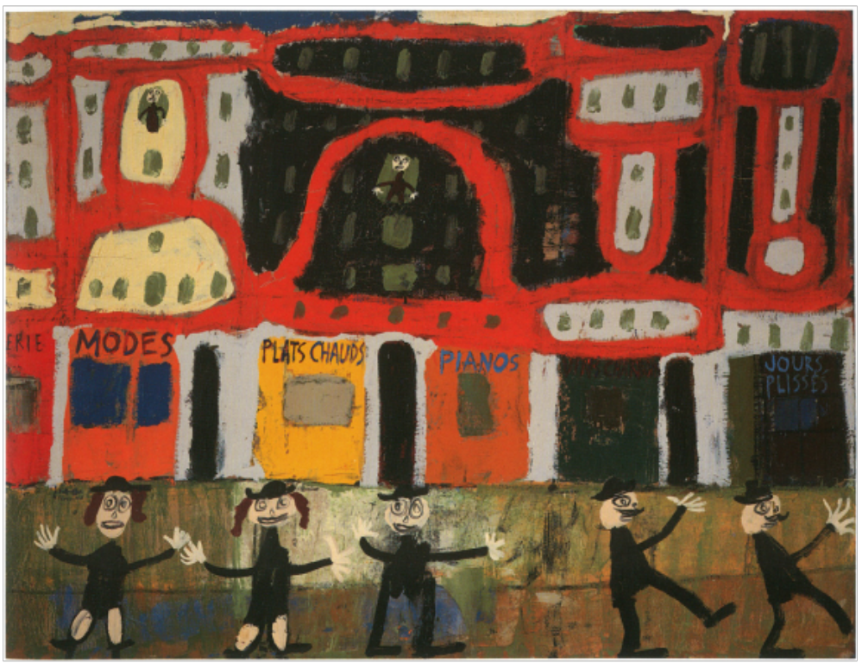
Fig. 1. Jean Dubuffet, Vue de Paris, la vie de plaisir, February 1944, Private collection.

- Copyright: Artists Rights Society (ARS), New York / ADAGP, Paris
Obtain image and image rights from: Fondation Dubuffet, Paris (Contact : Florence Quenu tél : 00 33 (0)1 47 34 12 63 fax : 00 33 (0)1 47 34 19 5

